AI ASSIGNMENT – 14

NAME:M. SUJITH
ROLL NO. : 2603A52396
BATCH : 14

Task 1 – Portfolio Website Design
You are building a personal portfolio website to showcase your work.
Requirements:
- Create sections for About Me, Projects, and Contact.
- Use AI to:
  - Suggest color palettes and typography.
  - Create a responsive layout with Grid/Flexbox.
  - Add smooth scrolling navigation.

PROMPT:
Create a polished, responsive personal portfolio website for a designer and front-end developer. Include About Me, Projects, and Contact sections, plus clear navigation. Use a warm off-white background, deep green accents, editorial typography, and clean project cards. Make it accessible, mobile-friendly, and easy to customize. Use semantic HTML, CSS, and minimal JavaScript in a single standalone file, without external libraries.

CODE:
from http.server import BaseHTTPRequestHandler, HTTPServer

HTML = """<!doctype html>
<html lang="en">
<head>
<meta charset="utf-8">
<meta name="viewport" content="width=device-width, initial-scale=1">
<title>Alex Morgan — Portfolio</title>
<style>
* { box-sizing: border-box; }
body {
margin: 0;
background: #f7f7f2;
color: #20231f;
font: 16px/1.6 system-ui, sans-serif;
}
.wrap { width: min(1000px, 90%); margin: auto; }
nav, .links, .contact, footer {
display: flex;
align-items: center;
justify-content: space-between;
gap: 20px;
}
nav { padding: 22px 0; }
a { color: inherit; }
nav a { text-decoration: none; }
.links { list-style: none; padding: 0; }
.hero { padding: 90px 0; }
.eyebrow { color: #2f684d; font-weight: 700; text-transform: uppercase; }
h1, h2 { font-family: Georgia, serif; font-weight: 500; line-height: 1.05; }
h1 { max-width: 700px; font-size: clamp(3rem, 9vw, 6rem); margin: 12px 0; }
h2 { font-size: clamp(2.2rem, 5vw, 3.5rem); }
.muted { color: #6b7069; }
.button {
display: inline-block; padding: 11px 18px; border-radius: 30px;
background: #2f684d; color: white; text-decoration: none;
}
section { padding: 55px 0; border-top: 1px solid #e5e7df; }
.grid { display: grid; grid-template-columns: repeat(2, 1fr); gap: 20px; }
.card { padding: 24px; border: 1px solid #e5e7df; border-radius: 14px; background: white; }
.contact { padding: 30px; border-radius: 14px; background: #e9eee4; }
footer { padding: 25px 0; color: #6b7069; font-size: .9rem; }
@media (max-width: 650px) {
.links { gap: 12px; }
.hero { padding: 60px 0; }
.grid { grid-template-columns: 1fr; }
.contact, footer { align-items: flex-start; flex-direction: column; }
}
</style>
</head>
<body>
<header class="wrap">
<nav aria-label="Main navigation">
<a href="#home"><strong>AM.</strong></a>
<ul class="links">
<li><a href="#about">About</a></li>
<li><a href="#projects">Projects</a></li>
<li><a href="#contact">Contact</a></li>
</ul>
</nav>
</header>

<main class="wrap">
<section class="hero" id="home" style="border: 0">
<p class="eyebrow">Designer &amp; developer</p>
<h1>I make digital things feel human.</h1>
<p class="muted">Hi, I’m Alex. I create useful, thoughtful experiences for the web.</p>
<a class="button" href="#projects">See my projects ↓</a>
</section>

<section id="about">
<p class="eyebrow">A little about me</p>
<h2>About me</h2>
<p class="muted">
I work across design and development to turn ideas into clear,
accessible digital products. I enjoy solving problems, learning new
things, and collaborating with good people.
</p>
<p><strong>Skills:</strong> Product design · UI/UX · HTML · CSS · JavaScript</p>
</section>

<section id="projects">
<p class="eyebrow">Selected work</p>
<h2>Projects</h2>
<div class="grid">
<article class="card">
<h3>Fieldnotes</h3>
<p class="muted">A simple planning tool that helps small teams organize work and share progress.</p>
</article>
<article class="card">
<h3>Good Ground</h3>
<p class="muted">A friendly website for a community garden and its neighborhood workshops.</p>
</article>
</div>
</section>

<section id="contact">
<div class="contact">
<div>
<p class="eyebrow">Let’s work together</p>
<h2>Have a project in mind?</h2>
<p class="muted">Send me a note—I’d love to hear about it.</p>
</div>
<a class="button" href="mailto:hello@example.com">Email me</a>
</div>
</section>
</main>

<footer class="wrap">
<span>© <span id="year"></span> Alex Morgan</span>
<span>Designed with care.</span>
</footer>
<script>document.getElementById("year").textContent = new Date().getFullYear();</script>
</body>
</html>
"""

class PortfolioHandler(BaseHTTPRequestHandler):
def do_GET(self):
page = HTML.encode("utf-8")
self.send_response(200)
self.send_header("Content-Type", "text/html; charset=utf-8")
self.send_header("Content-Length", str(len(page)))
self.end_headers()
self.wfile.write(page)

if __name__ == "__main__":
print("Open http://127.0.0.1:8000 in your browser.")
HTTPServer(("127.0.0.1", 8000), PortfolioHandler).serve_forever()
OUTPUT:
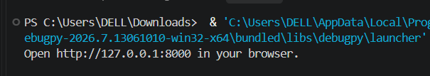

Task 2 – Online Store Product Page
Design a product display page for an online store.
Requirements:
- Display product image, title, price, and "Add to Cart" button.
- Use AI to:
  - Style with BEM methodology.
  - Make layout responsive.
  - Add hover effects and "Add to Cart" alert.
PROMPT :
Create a responsive online-store product page for a modern sneaker brand. Display a product image, title, price, short description, and “Add to Cart” button. Use BEM naming for all CSS classes, include responsive layouts and subtle hover effects, and show an alert when the button is clicked. Use accessible semantic HTML and keep the page self-contained with inline CSS and JavaScript
CODE:
<!doctype html>
<html lang="en">
<head>
<meta charset="utf-8">
<meta name="viewport" content="width=device-width, initial-scale=1">
<title>Solstice Runner — Northstar Goods</title>
<style>
* { box-sizing: border-box; }

body {
margin: 0;
background: #f7f7f2;
color: #20231f;
font: 16px/1.6 system-ui, sans-serif;
}

.site-header {
padding: 20px 6%;
border-bottom: 1px solid #e5e7df;
}

.site-header__brand {
color: #20231f;
font-weight: 800;
letter-spacing: .08em;
text-decoration: none;
}

.product {
display: grid;
grid-template-columns: 1fr 1fr;
gap: 48px;
align-items: center;
width: min(1050px, 88%);
margin: 64px auto;
}

.product__image-wrap {
overflow: hidden;
border-radius: 18px;
background: #e9eee4;
}

.product__image {
display: block;
width: 100%;
aspect-ratio: 1;
object-fit: cover;
transition: transform .3s ease;
}

.product__image-wrap:hover .product__image {
transform: scale(1.04);
}

.product__category {
color: #286343;
font-size: .8rem;
font-weight: 700;
letter-spacing: .12em;
text-transform: uppercase;
}

.product__title {
margin: 8px 0;
font: 500 clamp(2.5rem, 5vw, 4rem)/1 Georgia, serif;
}

.product__price {
font-size: 1.25rem;
font-weight: 700;
}

.product__description {
color: #70756f;
}

.product__button {
width: 100%;
padding: 15px 20px;
border: 0;
border-radius: 30px;
background: #286343;
color: white;
cursor: pointer;
font: inherit;
font-weight: 700;
transition: background .2s ease, transform .2s ease;
}

.product__button:hover {
transform: translateY(-2px);
background: #1d4e33;
}

.product__button:focus-visible {
outline: 3px solid #88a95a;
outline-offset: 3px;
}

.product__shipping {
color: #70756f;
font-size: .85rem;
text-align: center;
}

@media (max-width: 700px) {
.product {
grid-template-columns: 1fr;
gap: 28px;
margin: 32px auto;
}
}

@media (prefers-reduced-motion: reduce) {
*, *::before, *::after {
scroll-behavior: auto !important;
transition-duration: .01ms !important;
}
}
</style>
</head>
<body>
<header class="site-header">
<a class="site-header__brand" href="#">NORTHSTAR</a>
</header>

<main>
<article class="product">
<div class="product__image-wrap">
<img
class="product__image"
src="https://images.unsplash.com/photo-1542291026-7eec264c27ff?auto=format&fit=crop&w=1000&q=85"
alt="Red athletic sneaker"
>
</div>

<div class="product__details">
<p class="product__category">Everyday sneaker</p>
<h1 class="product__title">Solstice Runner</h1>
<p class="product__price">$89.00</p>
<p class="product__description">
A lightweight, comfortable sneaker made for everyday adventures.
Breathable materials and a cushioned sole keep you moving all day.
</p>
<button class="product__button" id="add-to-cart" type="button">
Add to Cart
</button>
<p class="product__shipping">Free shipping · Easy returns</p>
</div>
</article>
</main>

<script>
document.getElementById("add-to-cart").addEventListener("click", function () {
window.alert("Solstice Runner added to your cart!");
});
</script>
</body>
</html>

OUTPUT:
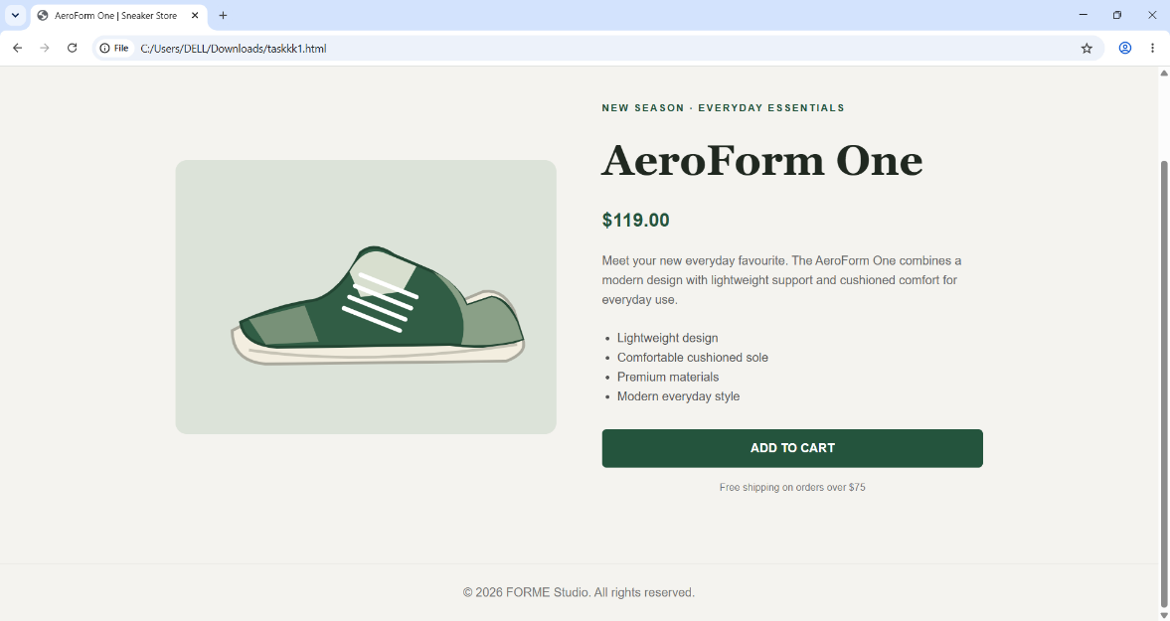

Task 3 – Event Registration Form
Build an event registration form for a conference.
Requirements:
- Collect name, email, phone number, and session selection.
- Use AI to:
  - Add form validation with JavaScript.
  - Make the form accessible with labels and ARIA.
  - Style with a professional look.

PROMPT:
Build a professional, responsive conference registration form using HTML, CSS, and JavaScript. Collect the attendee’s full name, email address, phone number, and preferred conference session. Add clear labels associated with every field, semantic form elements, and appropriate ARIA attributes for accessibility. Validate the required fields and input formats with JavaScript, display helpful inline error messages, and clearly confirm successful registration. Use a clean, polished design that works well on desktop and mobile. Keep the code self-contained in one HTML file.
CODE:
<!doctype html>
<html lang="en">
<head>
<meta charset="utf-8">
<meta name="viewport" content="width=device-width, initial-scale=1">
<title>Conference Registration</title>
<style>
* { box-sizing: border-box; }

body {
margin: 0;
padding: 40px 16px;
background: #f3f5f8;
color: #202b3c;
font: 16px/1.5 system-ui, sans-serif;
}

.registration {
max-width: 620px;
margin: 0 auto;
padding: 36px;
border: 1px solid #e1e6ed;
border-radius: 16px;
background: #fff;
box-shadow: 0 12px 36px #26364a12;
}

.registration__eyebrow {
margin: 0 0 8px;
color: #315f9b;
font-size: .8rem;
font-weight: 700;
letter-spacing: .1em;
text-transform: uppercase;
}

.registration__title {
margin: 0;
font-size: clamp(1.8rem, 5vw, 2.5rem);
}

.registration__intro {
margin: 10px 0 28px;
color: #5d6878;
}

.registration__field { margin-bottom: 20px; }

.registration__label {
display: block;
margin-bottom: 7px;
font-weight: 650;
}

.registration__input,
.registration__select {
width: 100%;
min-height: 48px;
padding: 10px 12px;
border: 1px solid #aeb8c6;
border-radius: 8px;
background: #fff;
color: #202b3c;
font: inherit;
}

.registration__input:focus,
.registration__select:focus {
border-color: #315f9b;
outline: 3px solid #315f9b33;
}

.registration__input[aria-invalid="true"],
.registration__select[aria-invalid="true"] {
border-color: #b42318;
}

.registration__hint {
display: block;
margin-top: 5px;
color: #5d6878;
font-size: .85rem;
}

.registration__error {
display: block;
min-height: 1.3em;
margin-top: 4px;
color: #b42318;
font-size: .88rem;
}

.registration__button {
width: 100%;
min-height: 50px;
border: 0;
border-radius: 8px;
background: #245c9b;
color: white;
cursor: pointer;
font: inherit;
font-weight: 700;
transition: background .2s ease, transform .2s ease;
}

.registration__button:hover {
transform: translateY(-1px);
background: #194879;
}

.registration__button:focus-visible {
outline: 3px solid #315f9b66;
outline-offset: 3px;
}

.registration__status {
margin: 18px 0 0;
color: #17633a;
font-weight: 650;
}

@media (max-width: 480px) {
body { padding: 20px 12px; }
.registration { padding: 24px 18px; }
}

@media (prefers-reduced-motion: reduce) {
*, *::before, *::after {
scroll-behavior: auto !important;
transition-duration: .01ms !important;
}
}
</style>
</head>
<body>
<main>
<form class="registration" id="registration-form" novalidate>
<p class="registration__eyebrow">Annual technology conference</p>
<h1 class="registration__title">Register to attend</h1>
<p class="registration__intro">Complete the form to reserve your place.</p>

<div class="registration__field">
<label class="registration__label" for="full-name">Full name</label>
<input
class="registration__input"
id="full-name"
name="fullName"
type="text"
autocomplete="name"
required
aria-describedby="name-error"
aria-invalid="false"
>
<span class="registration__error" id="name-error"></span>
</div>

<div class="registration__field">
<label class="registration__label" for="email">Email address</label>
<input
class="registration__input"
id="email"
name="email"
type="email"
autocomplete="email"
required
aria-describedby="email-error"
aria-invalid="false"
>
<span class="registration__error" id="email-error"></span>
</div>

<div class="registration__field">
<label class="registration__label" for="phone">Phone number</label>
<input
class="registration__input"
id="phone"
name="phone"
type="tel"
autocomplete="tel"
inputmode="tel"
required
aria-describedby="phone-hint phone-error"
aria-invalid="false"
>
<span class="registration__hint" id="phone-hint">
Include your country code if registering internationally.
</span>
<span class="registration__error" id="phone-error"></span>
</div>

<div class="registration__field">
<label class="registration__label" for="session">Choose a session</label>
<select
class="registration__select"
id="session"
name="session"
required
aria-describedby="session-error"
aria-invalid="false"
>
<option value="">Select a session</option>
<option value="ai-and-innovation">AI &amp; Innovation</option>
<option value="web-development">Modern Web Development</option>
<option value="design-accessibility">Design &amp; Accessibility</option>
</select>
<span class="registration__error" id="session-error"></span>
</div>

<button class="registration__button" type="submit">Register</button>
<p
class="registration__status"
id="form-status"
role="status"
aria-live="polite"
></p>
</form>
</main>

<script>
const form = document.getElementById("registration-form");
const statusMessage = document.getElementById("form-status");

const fields = {
fullName: {
input: document.getElementById("full-name"),
error: document.getElementById("name-error")
},
email: {
input: document.getElementById("email"),
error: document.getElementById("email-error")
},
phone: {
input: document.getElementById("phone"),
error: document.getElementById("phone-error")
},
session: {
input: document.getElementById("session"),
error: document.getElementById("session-error")
}
};

function showError(field, message) {
field.error.textContent = message;
field.input.setAttribute("aria-invalid", message ? "true" : "false");
}

form.addEventListener("submit", function (event) {
event.preventDefault();
statusMessage.textContent = "";

const name = fields.fullName.input.value.trim();
const email = fields.email.input.value.trim();
const phone = fields.phone.input.value.trim();
const session = fields.session.value;
let firstInvalidField = null;

Object.values(fields).forEach(function (field) {
showError(field, "");
});

if (!name) {
showError(fields.fullName, "Enter your full name.");
firstInvalidField = firstInvalidField || fields.fullName.input;
}

const emailPattern = /^[^\s@]+@[^\s@]+\.[^\s@]+$/;
if (!email) {
showError(fields.email, "Enter your email address.");
firstInvalidField = firstInvalidField || fields.email.input;
} else if (!emailPattern.test(email)) {
showError(fields.email, "Enter a valid email address.");
firstInvalidField = firstInvalidField || fields.email.input;
}

const phonePattern = /^\+?[\d\s().-]+$/;
const digitCount = phone.replace(/\D/g, "").length;
if (!phone) {
showError(fields.phone, "Enter your phone number.");
firstInvalidField = firstInvalidField || fields.phone.input;
} else if (!phonePattern.test(phone) || digitCount < 7 || digitCount > 15) {
showError(fields.phone, "Enter a valid phone number with 7–15 digits.");
firstInvalidField = firstInvalidField || fields.phone.input;
}

if (!session) {
showError(fields.session, "Choose a conference session.");
firstInvalidField = firstInvalidField || fields.session.input;
}

if (firstInvalidField) {
firstInvalidField.focus();
return;
}

statusMessage.textContent =
"Thanks, " + name + "! Your form is complete. This demo does not submit your registration to a server.";
form.reset();
Object.values(fields).forEach(function (field) {
field.input.setAttribute("aria-invalid", "false");
});
});
</script>
</body>
</html>

OUTPUT:
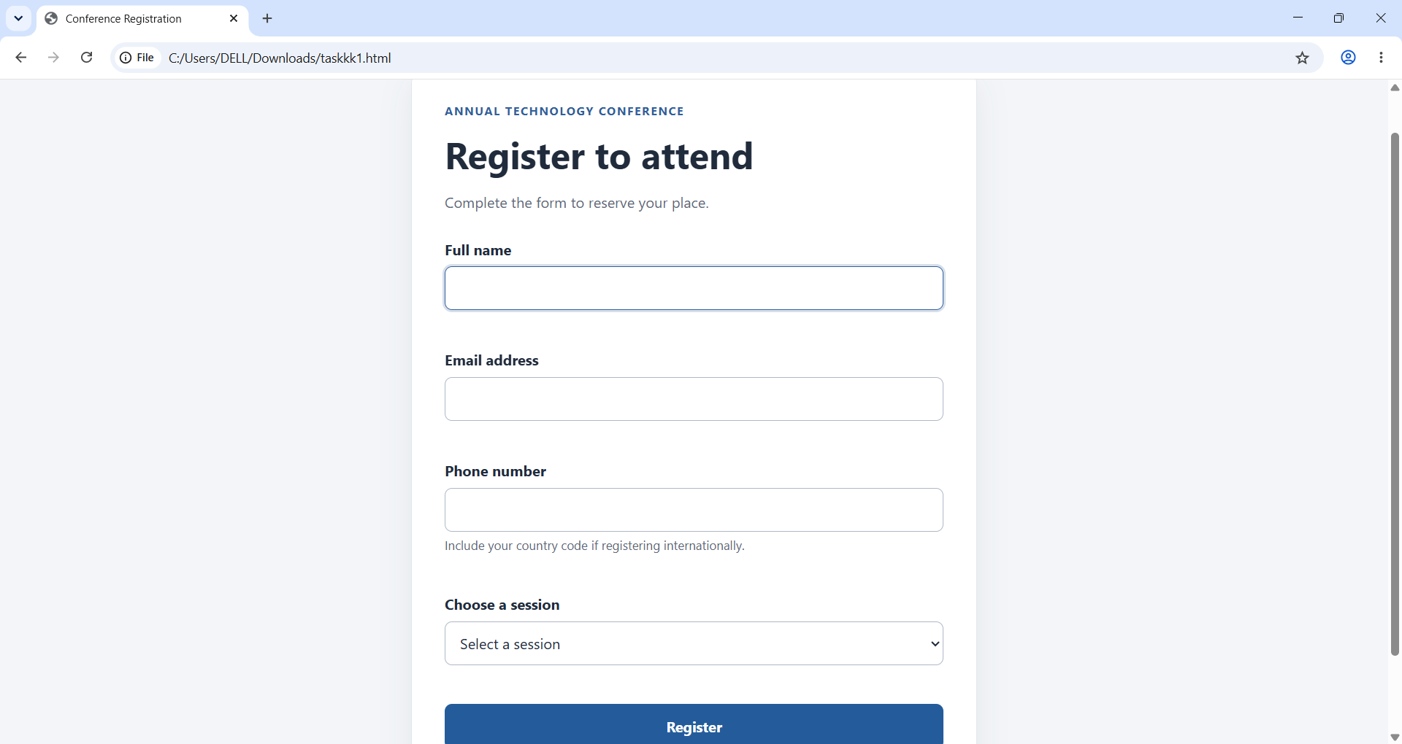
Task 4 – Resume Website
Build a one-page online resume.
Requirements:
- Sections: Profile Summary, Skills, Education, Experience.
- Use AI to:
  - Propose professional typography styles.
  - Align sections using CSS Grid.
  - Add smooth scroll navigation between sections.
PROMPT :
Build a professional, responsive, one-page online resume website using HTML and CSS. Include clearly organized sections for Profile Summary, Skills, Education, and Experience, with a navigation menu linking to each section. Use CSS Grid to align the page layout and smooth scrolling for navigation. Propose a polished typography pairing—such as a clean sans-serif for body text and an elegant serif for headings—with accessible contrast and readable font sizes. Use semantic HTML, responsive styling for mobile and desktop, and placeholder content that is easy to personalize. Keep the code self-contained in one HTML file.
CODE:
<!doctype html>
<html lang="en">
<head>
<meta charset="utf-8">
<meta name="viewport" content="width=device-width, initial-scale=1">
<meta name="description" content="Online resume for Jordan Lee, software developer.">
<title>Jordan Lee — Resume</title>
<style>
:root {
--ink: #202a35;
--muted: #647181;
--accent: #285d78;
--paper: #f4f6f8;
--surface: #fff;
--line: #e1e6eb;
--heading-font: Georgia, "Times New Roman", serif;
--body-font: Arial, Helvetica, sans-serif;
}

* { box-sizing: border-box; }

html {
scroll-behavior: smooth;
scroll-padding-top: 85px;
}

body {
margin: 0;
background: var(--paper);
color: var(--ink);
font: 16px/1.65 var(--body-font);
}

a { color: var(--accent); }

.header {
position: sticky;
top: 0;
z-index: 1;
border-bottom: 1px solid var(--line);
background: #ffffffed;
}

.header__inner,
.resume {
width: min(1000px, calc(100% - 40px));
margin: 0 auto;
}

.header__inner {
display: flex;
min-height: 68px;
align-items: center;
justify-content: space-between;
gap: 20px;
}

.header__name {
color: var(--ink);
font-weight: 700;
text-decoration: none;
}

.nav {
display: flex;
flex-wrap: wrap;
gap: 20px;
}

.nav__link {
color: var(--muted);
font-size: .9rem;
text-decoration: none;
}

.nav__link:hover { color: var(--accent); }

.resume { padding: 48px 0; }

.resume__intro {
padding: 38px;
border: 1px solid var(--line);
border-radius: 14px;
background: var(--surface);
}

.resume__eyebrow {
margin: 0 0 8px;
color: var(--accent);
font-size: .8rem;
font-weight: 700;
letter-spacing: .12em;
text-transform: uppercase;
}

.resume__title,
.section__title {
font-family: var(--heading-font);
font-weight: 500;
line-height: 1.15;
}

.resume__title {
margin: 0;
font-size: clamp(2.5rem, 7vw, 4rem);
}

.resume__role {
margin: 8px 0 0;
color: var(--muted);
font-size: 1.15rem;
}

.resume__contact {
display: flex;
flex-wrap: wrap;
gap: 8px 22px;
margin-top: 20px;
color: var(--muted);
font-size: .92rem;
}

.resume__grid {
display: grid;
grid-template-columns: minmax(0, 1fr) minmax(260px, .7fr);
gap: 22px;
margin-top: 22px;
}

.resume__main,
.resume__side {
display: grid;
align-content: start;
gap: 22px;
}

.section {
padding: 26px;
border: 1px solid var(--line);
border-radius: 14px;
background: var(--surface);
scroll-margin-top: 88px;
}

.section__title {
margin: 0 0 16px;
font-size: 1.65rem;
}

.section p { margin: 0; color: var(--muted); }

.skills {
display: flex;
flex-wrap: wrap;
gap: 9px;
margin: 0;
padding: 0;
list-style: none;
}

.skills__item {
padding: 6px 11px;
border: 1px solid var(--line);
border-radius: 999px;
background: #f8fafb;
font-size: .88rem;
}

.entry + .entry {
margin-top: 22px;
padding-top: 20px;
border-top: 1px solid var(--line);
}

.entry__title { margin: 0; font-size: 1.05rem; }
.entry__meta { margin: 3px 0 8px !important; color: var(--accent) !important; font-size: .9rem; }
.entry__description { margin: 0; padding-left: 19px; color: var(--muted); }
.entry__description li + li { margin-top: 5px; }

.footer {
padding: 20px;
color: var(--muted);
font-size: .85rem;
text-align: center;
}

:focus-visible {
outline: 3px solid #6b9eb6;
outline-offset: 4px;
}

@media (max-width: 700px) {
.header__inner {
align-items: flex-start;
flex-direction: column;
justify-content: center;
padding: 12px 0;
}

.nav { gap: 10px 16px; }
.resume { padding: 28px 0; }
.resume__intro { padding: 26px; }
.resume__grid { grid-template-columns: 1fr; }
}

@media (prefers-reduced-motion: reduce) {
html { scroll-behavior: auto; }
}
</style>
</head>
<body>
<header class="header">
<div class="header__inner">
<a class="header__name" href="#profile">Jordan Lee</a>
<nav class="nav" aria-label="Resume sections">
<a class="nav__link" href="#profile">Profile</a>
<a class="nav__link" href="#skills">Skills</a>
<a class="nav__link" href="#education">Education</a>
<a class="nav__link" href="#experience">Experience</a>
</nav>
</div>
</header>

<main class="resume">
<section class="resume__intro" id="profile" aria-labelledby="profile-title">
<p class="resume__eyebrow">Online resume</p>
<h1 class="resume__title" id="profile-title">Jordan Lee</h1>
<p class="resume__role">Software Developer</p>
<div class="resume__contact">
<a href="mailto:jordan.lee@example.com">jordan.lee@example.com</a>
<span>Portland, Oregon</span>
<a href="https://www.linkedin.com/">LinkedIn profile</a>
</div>
</section>

<div class="resume__grid">
<div class="resume__main">
<section class="section" aria-labelledby="summary-title">
<h2 class="section__title" id="summary-title">Profile Summary</h2>
<p>
Curious and detail-oriented software developer with experience
building accessible, reliable web applications. I enjoy turning
complex problems into clear solutions and working closely with
multidisciplinary teams.
</p>
</section>

<section class="section" id="experience" aria-labelledby="experience-title">
<h2 class="section__title" id="experience-title">Experience</h2>

<article class="entry">
<h3 class="entry__title">Software Developer · Example Studio</h3>
<p class="entry__meta">2023–Present · Portland, Oregon</p>
<ul class="entry__description">
<li>Develop and maintain responsive web features.</li>
<li>Collaborate with designers and teammates to improve user experience.</li>
<li>Write clear, testable code and contribute to code reviews.</li>
</ul>
</article>

<article class="entry">
<h3 class="entry__title">Junior Web Developer · Brightside Digital</h3>
<p class="entry__meta">2021–2023 · Remote</p>
<ul class="entry__description">
<li>Built and updated client websites using modern web technologies.</li>
<li>Improved accessibility, mobile layouts, and page performance.</li>
</ul>
</article>
</section>
</div>

<aside class="resume__side">
<section class="section" id="skills" aria-labelledby="skills-title">
<h2 class="section__title" id="skills-title">Skills</h2>
<ul class="skills">
<li class="skills__item">HTML &amp; CSS</li>
<li class="skills__item">JavaScript</li>
<li class="skills__item">Python</li>
<li class="skills__item">React</li>
<li class="skills__item">Git</li>
<li class="skills__item">Accessibility</li>
<li class="skills__item">Responsive design</li>
</ul>
</section>

<section class="section" id="education" aria-labelledby="education-title">
<h2 class="section__title" id="education-title">Education</h2>
<article class="entry">
<h3 class="entry__title">B.S. in Computer Science</h3>
<p class="entry__meta">Northwest University · 2017–2021</p>
<p>Relevant study: software engineering, databases, and human-computer interaction.</p>
</article>
</section>
</aside>
</div>
</main>

<footer class="footer">
<p>© 2025 Jordan Lee</p>
</footer>
</body>
</html>
OUTPUT :
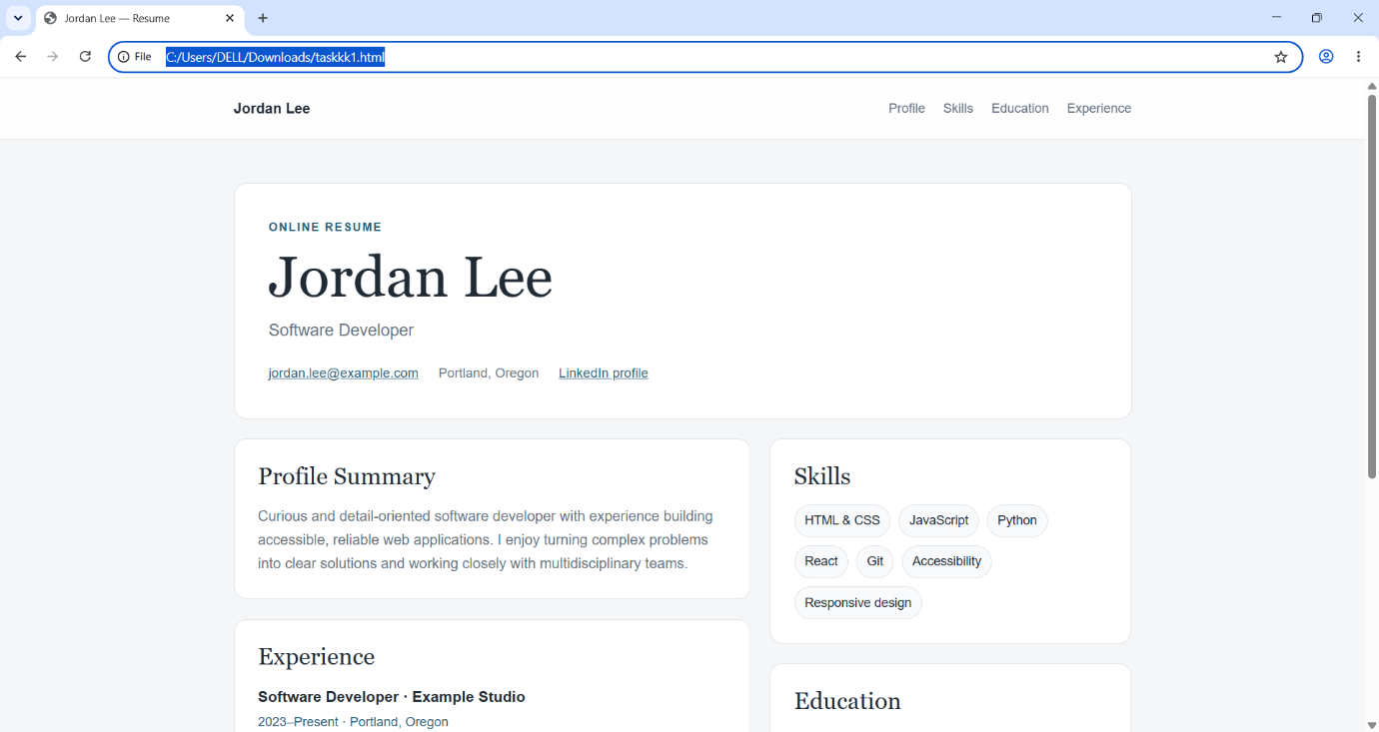

Task 5 – Restaurant Menu Page
Design a digital menu page for a restaurant.
Requirements:
- Display menu items with name, description, and price.
- Use AI to:
  - Suggest a food-friendly color palette.
  - Design a responsive card-based layout.
  - Add hover effects on menu items.
PROMPT:
Create a polished, responsive digital menu page for a restaurant using a card-based layout. Display menu items with a name, appetizing description, and clearly visible price. Use a food-friendly color palette—warm cream, herb green, and muted tomato red—with strong contrast and readable typography. Add subtle hover effects to menu cards and ensure the layout adapts gracefully to mobile and desktop screens. Use semantic, accessible HTML and keep the code in a single HTML file with embedded CSS. Include sample items organized into menu categories, and make the content easy to customize.
CODE:
<!doctype html>
<html lang="en">
<head>
<meta charset="utf-8">
<meta name="viewport" content="width=device-width, initial-scale=1">
<meta name="description" content="Seasonal dishes at The Garden Table restaurant.">
<title>Menu — The Garden Table</title>
<style>
:root {
--cream: #faf6ed;
--card: #fffdf8;
--green: #355b42;
--tomato: #bd583f;
--ink: #292d27;
--muted: #73766d;
--line: #e8e1d4;
}

* { box-sizing: border-box; }

body {
margin: 0;
background: var(--cream);
color: var(--ink);
font: 16px/1.6 system-ui, sans-serif;
}

.menu-page {
width: min(1050px, calc(100% - 36px));
margin: 0 auto;
padding: 48px 0 64px;
}

.menu-header {
margin-bottom: 42px;
text-align: center;
}

.menu-header__eyebrow {
margin: 0 0 8px;
color: var(--tomato);
font-size: .8rem;
font-weight: 750;
letter-spacing: .16em;
text-transform: uppercase;
}

.menu-header__title {
margin: 0;
color: var(--green);
font: 500 clamp(2.8rem, 8vw, 5rem)/1.05 Georgia, serif;
}

.menu-header__intro {
max-width: 550px;
margin: 14px auto 0;
color: var(--muted);
}

.menu-section { margin-top: 40px; }

.menu-section__title {
margin: 0 0 18px;
padding-bottom: 10px;
border-bottom: 1px solid var(--line);
color: var(--green);
font: 500 1.8rem Georgia, serif;
}

.menu-grid {
display: grid;
grid-template-columns: repeat(2, minmax(0, 1fr));
gap: 16px;
}

.menu-item {
display: flex;
justify-content: space-between;
gap: 20px;
padding: 22px;
border: 1px solid var(--line);
border-radius: 14px;
background: var(--card);
transition: transform .2s ease, box-shadow .2s ease, border-color .2s ease;
}

.menu-item:hover {
transform: translateY(-4px);
border-color: #c9d2c4;
box-shadow: 0 12px 26px #473c2512;
}

.menu-item__name {
margin: 0 0 5px;
font-size: 1.08rem;
}

.menu-item__description {
margin: 0;
color: var(--muted);
font-size: .92rem;
}

.menu-item__price {
flex-shrink: 0;
color: var(--tomato);
font-weight: 750;
}

.menu-footer {
margin-top: 46px;
color: var(--muted);
font-size: .88rem;
text-align: center;
}

@media (max-width: 650px) {
.menu-page { padding-top: 32px; }
.menu-header { margin-bottom: 32px; }
.menu-grid { grid-template-columns: 1fr; }
.menu-item { padding: 18px; }
}

@media (prefers-reduced-motion: reduce) {
*, *::before, *::after {
scroll-behavior: auto !important;
transition-duration: .01ms !important;
}
}
</style>
</head>
<body>
<main class="menu-page">
<header class="menu-header">
<p class="menu-header__eyebrow">Fresh · Local · Seasonal</p>
<h1 class="menu-header__title">The Garden Table</h1>
<p class="menu-header__intro">
Thoughtful food made with ingredients from our favorite local farms.
</p>
</header>

<section class="menu-section" aria-labelledby="starters-title">
<h2 class="menu-section__title" id="starters-title">To Start</h2>
<div class="menu-grid">
<article class="menu-item">
<div>
<h3 class="menu-item__name">Whipped Ricotta</h3>
<p class="menu-item__description">Local honey, roasted grapes, grilled sourdough.</p>
</div>
<span class="menu-item__price">$12</span>
</article>

<article class="menu-item">
<div>
<h3 class="menu-item__name">Market Greens</h3>
<p class="menu-item__description">Crisp seasonal leaves, herbs, lemon vinaigrette.</p>
</div>
<span class="menu-item__price">$11</span>
</article>
</div>
</section>

<section class="menu-section" aria-labelledby="mains-title">
<h2 class="menu-section__title" id="mains-title">From the Kitchen</h2>
<div class="menu-grid">
<article class="menu-item">
<div>
<h3 class="menu-item__name">Roasted Tomato Pasta</h3>
<p class="menu-item__description">Handmade pasta, slow-roasted tomatoes, basil, parmesan.</p>
</div>
<span class="menu-item__price">$22</span>
</article>

<article class="menu-item">
<div>
<h3 class="menu-item__name">Garden Risotto</h3>
<p class="menu-item__description">Creamy arborio rice, spring vegetables, fresh herbs.</p>
</div>
<span class="menu-item__price">$24</span>
</article>

<article class="menu-item">
<div>
<h3 class="menu-item__name">Herb-Roasted Chicken</h3>
<p class="menu-item__description">Free-range chicken, crisp potatoes, seasonal greens.</p>
</div>
<span class="menu-item__price">$27</span>
</article>

<article class="menu-item">
<div>
<h3 class="menu-item__name">Mushroom Toast</h3>
<p class="menu-item__description">Wild mushrooms, garlic, thyme, toasted country bread.</p>
</div>
<span class="menu-item__price">$19</span>
</article>
</div>
</section>

<section class="menu-section" aria-labelledby="desserts-title">
<h2 class="menu-section__title" id="desserts-title">Something Sweet</h2>
<div class="menu-grid">
<article class="menu-item">
<div>
<h3 class="menu-item__name">Olive Oil Cake</h3>
<p class="menu-item__description">Citrus, soft cream, a little powdered sugar.</p>
</div>
<span class="menu-item__price">$10</span>
</article>

<article class="menu-item">
<div>
<h3 class="menu-item__name">Seasonal Fruit Sorbet</h3>
<p class="menu-item__description">House-made sorbet with fresh market fruit.</p>
</div>
<span class="menu-item__price">$8</span>
</article>
</div>
</section>

<footer class="menu-footer">
Please let our team know about any allergies or dietary requirements.
</footer>
</main>
</body>
</html>
OUTPUT:


